**DP2 2020-2021**

Lint Report

June Group #4

Repository

<https://github.com/rodddella/Acme-Planner.git>

Members

* Guillermo Diz Gil (Manager, developer, tester)
* Francisco Rodríguez Pérez (Developer, tester)
* Carmen María Muñoz Pérez (Developer, tester)
* George Laurentiu Bogdan (Developer, tester)

Tutor

* Rafael Corchuelo Gil

Table of contents

Summary 3

Bad smells 4

Remove useless curly braces around statement 4

Complete the task associated to this TODO comment 4

Rename “threshold” which hides the field declared at line 14 5

Cast one of the operands of this multiplication operation to a “long” 5

About the Bootstrap bundle 6

Summary

This document will show and detail the bad smells found by SonarLint in our project. These will be analysed and solved.

# Bad smells

SonarLint has found four bad smells in our project, though the used Bootstrap bundle seems to have many of them, which will be discussed later in the document. Each of them will be analysed below. these smells are shown in the following image

## Remove useless curly braces around statement

This bad smell occurs when you write a lambda expression in a less compact and readable way.

This bad smell is not serious, since both ways of writing the lambda expression are very similar.

To solve it, this more compact way of writing the expression has been used.

More compact lambda expression

## Complete the task associated to this TODO comment

This bad smell occurs when code in a method is required, but not yet implemented, or the developer has forgotten to remove the "TODO Auto-generated method stub" tag.

This bad smell is informative, so it is not serious, and it helps you to notice if a method has not been completed. In our case it was because the tag was not removed, because the method was complete.

So, it would only be necessary to delete that comment.

Method with “TODO Auto-generated method stub" tag remove

## Rename “threshold” which hides the field declared at line 14

This bad smell occurs when a variable declared in an external scope is overwritten or shadowed.

Thus, this situation can affect both readability and maintainability of the code. Because of this, a developer could confuse variables and use them in the wrong way.

This bad smell is serious, as confusing variables can cause chaos for developers working with the code, especially if it is not originally yours. To fix it, simply rename those variables.

Variable rename from “threshold” to “myThreshold”

## Cast one of the operands of this multiplication operation to a “long”

This bad smell occurs when operating on a given type and then assigning another type to the result. In our case, we operate on integers and the result is assigned to a variable of type long.

This situation can cause erroneous results. For example, if we operate on the type int and then assign it to a long variable, the result could overflow before the assignment. Therefore, this is an important situation to be aware of.

To solve it, you only have to transform one of the operands used to the type of the resulting variable. In our case it is a product of three integer factors, so one of them will have to be converted to long.

## About the Bootstrap bundle

As can be seen in the image, the Bootstrap bundle appears to have several code smells. These are detected due to the rules that SonarLint has activated by default for JS programming language. However, we will ignore these code smells, since it is a packaged library and ready to consume, we should not modify or alter its source code.

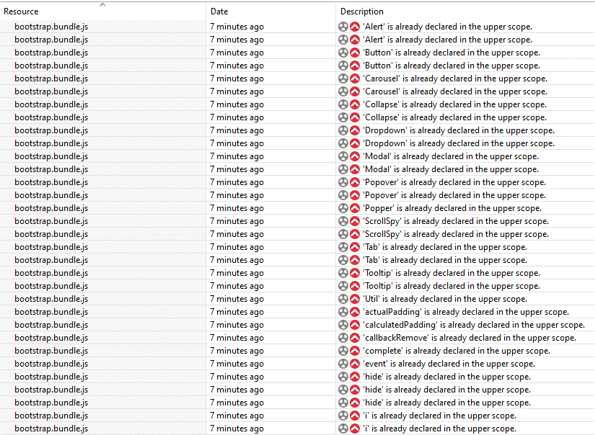

Bad smells found in Bootstrap bundle